Machrihanish Seabird Observatory
Established 1993
25 Years old on 11th September 2018

February Report 2018

Compiled by Eddie Maguire (Warden)
Photo of the month...
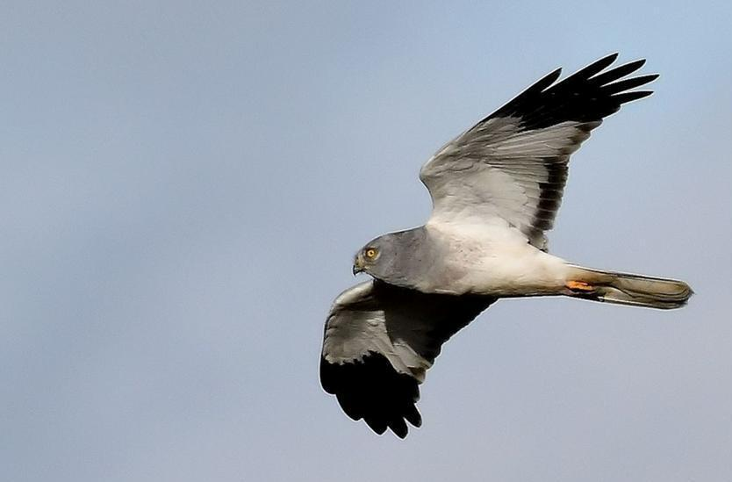
- Hen Harrier at Bleachfield TL 12th February

This report includes photographs of Hen Harriers at The Laggan (TL) Juncus roost again along with records received from around Kintyre by a few regular contributors and records from Argyll Bird Club’s website.

Grand News; an update on the Sooty Tern at MSBO seen/photographed by Eddie Maguire on 2nd June 2017….this record has recently been accepted by the British Birds Rarities Committee and is now an additional species to the Argyll list which now stands at 355 (per Jim Dickson / Argyll Recorder and Argyll Bird Cub Website).

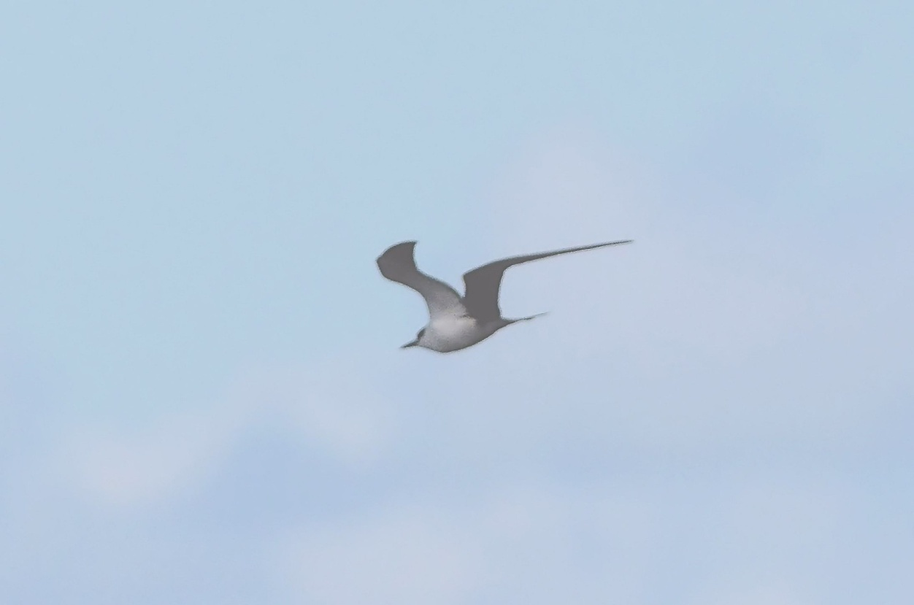
- Tropical vagrant - The Sooty Tern off MSBO 2nd June 2017
- First Argyll record
- Third Scottish occurrence

Long awaited news; notification has been received re details of the French-ringed Goldfinch that was trapped at MSBO last spring.
Ring no. Paris 8158019. Ringed on 11th February 2017 at Les Roberts, Liart, Ardennes, France.
Controlled at MSBO on 19th April 2017.
Duration: 67 days Distance: 925km Direction: 313deg (NW).

More news re the orange neck-collared Greylag Goose (marked B|PJ) that was collared/ringed at Threecastles, Poulaphouca, Co. Wicklow, Ireland in December 2015. The bird was photographed at Strath Farm, by Stewarton TL on 19th November 2017 and was seen back at Poulaphouca, Co. Wicklow on 26th January 2018 (per Niamh Fitzgerald / Irish Greylag Geese).

List of selected species for February

Common Shelduck
Bleachfield Farm TL; a pair were regular all month.

Eurasian Wigeon
Campbeltown Loch: 33 on 7th.

Hen Harrier
Bleachfield Farm TL; 4 birds (3m / 1f) were regularly seen/photographed foraging and going down to roost in large area of Juncus.
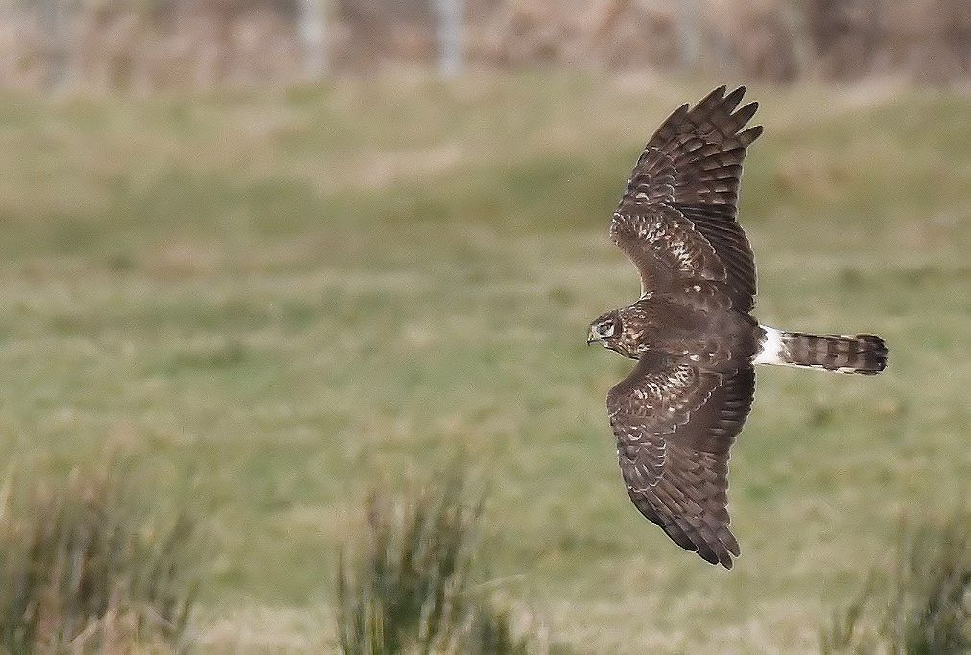
- Hen Harrier; Bleachfield TL 3rd February

Peregrine Falcon
Bleachfield TL; an adult on 6th.

Merlin
Singles at Bleachfield TL; on 5th, 9th (Brian Morton pers. comm), 11th, 15th and 23rd.

Golden Plover
Bleachfield TL; 210 on 23rd. 400+ on 25th.

Lapwing
Bleachfield TL; 38 on 23rd.

Iceland Gull
Campbeltown Harbour; the adult found here on 27th January was present on 1st and seen on 9 dates later to 25th.
A first-winter (2CY) was loafing on the pontoon by the harbour on 9th.
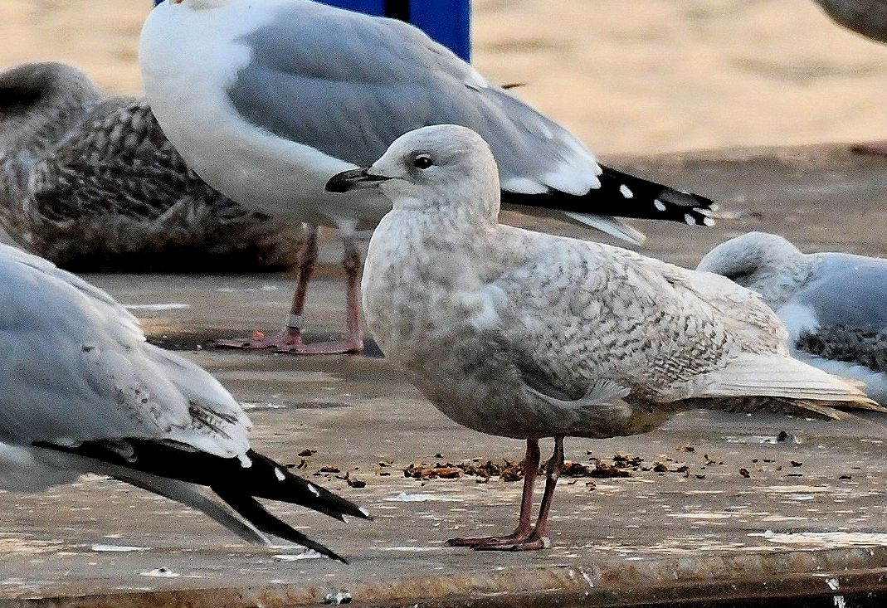
- Iceland Gull (first-winter) at Campbeltown Harbour pontoon 9th February
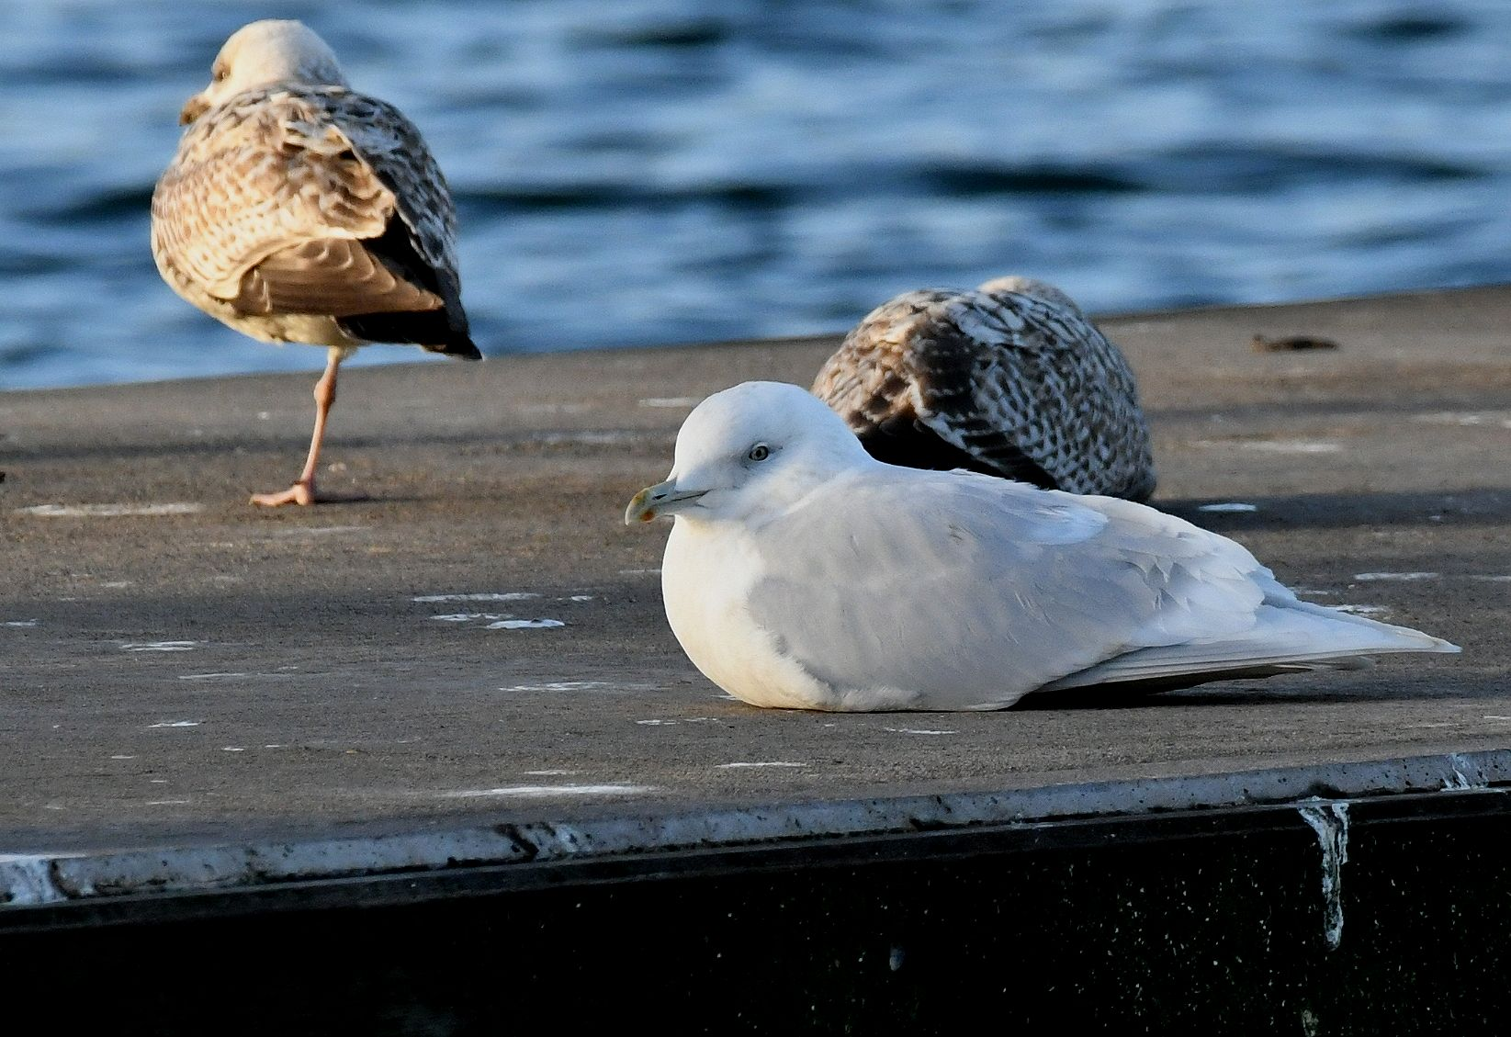
- Iceland Gull (adult) Campbeltown Harbour pontoon 20th February

Glaucous Gull
Tarbert; a first-winter at the harbour on 5th and 9th.
Kennacraig; a first-winter on 10th (both records per Argyll Bird Club website).

European Stonechat
Bleachfield TL; One’s and two’s seen on all visits.
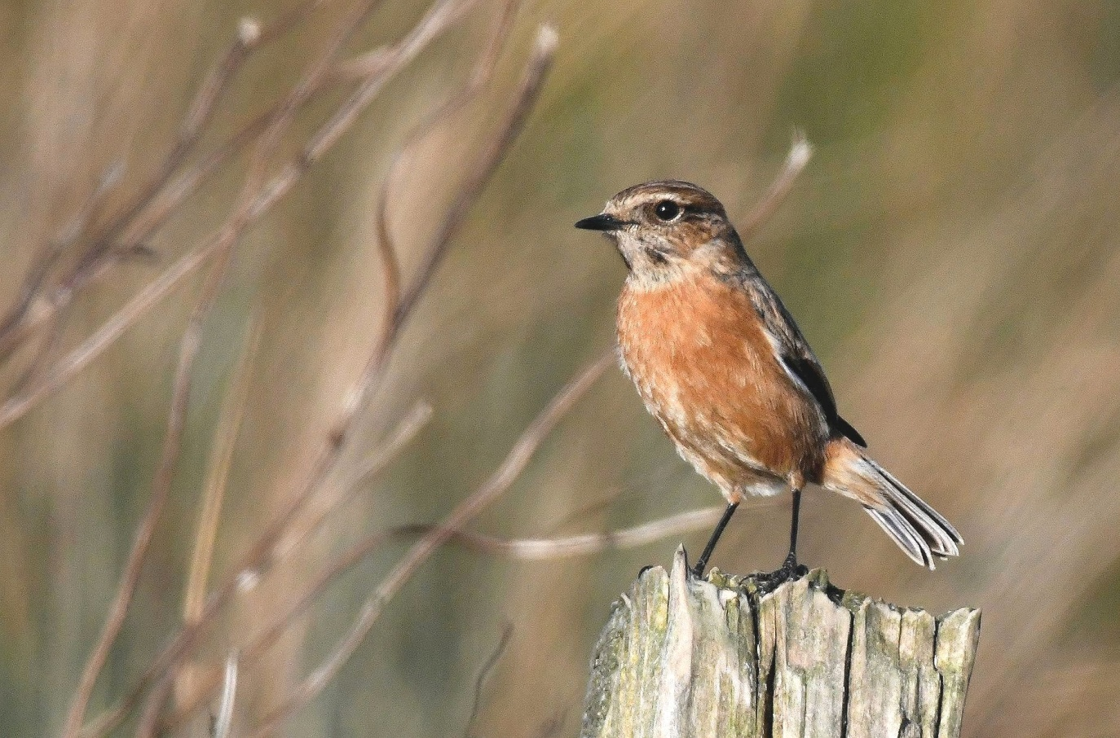
- Stonechat at Bleachfield TL 20th February

Kingfisher
Kennacraig; one on 3rd (per Argyll Bird Club website).

Jackdaw
Bleachfield TL; ca. 700 >E / 25mins on 25th.

Rook
Bleachfield TL; ca. 2,000 >E / 25mins on 25th.
This species (and Jackdaw above) were heading for traditional winter roost site at Kildalloig Estate; this is on the south bank at the entrance to Campbeltown Loch.

Common Raven
Bleachfield Farm TL; two pairs were displaying on 15th.

Twite
A male colour ringed at MSBO in October 2014 is still performing well on trips to NE Wales and back to MSBO and has accumulated an interesting history of doing so....
BTO ring = L586170 + green colour ring 22E.
Ringed MSBO on 10th October 2014.
Controlled at Connah’s Quay, Flintshire, NE Wales on 14th and 25th March 2015. Additional rings were added to this bird when it was controlled in Wales / see photo below.
Retrapped at MSBO on 14th October 2015.
Controlled at Connah’s Quay on 12th February and 11th March 2016.
Retrapped at MSBO on 28th September 2016.
Controlled at Connah’s Quay on 20th January and 15th February 2017.
Retrapped at MSBO on 7th April 2017.
Retrapped at MSBO again on passage from breeding grounds on 3 dates 4th – 10th October 2017.
On its way to Flintshire again?
It certainly was and was controlled again at Connah’s Quay on 1st February 2018.
Connah’s Quay (Flintshire) is 298km SSE of MSBO. So far, the seven single journeys completed by this male Twite amounts to at least 2,086km.

Yellowhammer
Southend; 1-3 at garden feeding station all month (Roy / Susie Bennet pers. comm.).
Campbeltown; 2 at garden feeding station all month (Graham / Esther Thompson pers. comm.).

Reed Bunting
Bleachfield Farm TL; 7 on 2nd. This flock increased to 11 by 9th. Regularly seen at this site.
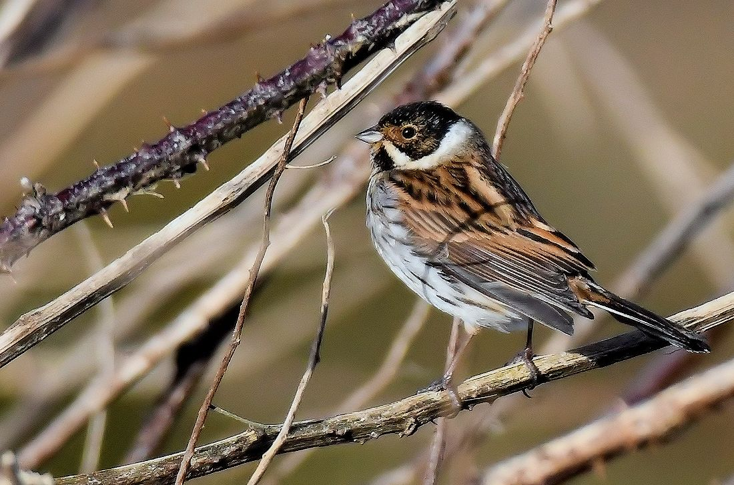
- Reed Bunting (male) at Bleachfield TL 9th February

The Bleachfield Hen Harriers...
The following photographs were taken at Bleachfield Farm TL ca. 3 miles west of Campbeltown.
This newly discovered roost has probably been in use since the traditional roost at nearby Aros Moss was largely abandoned. It has also likely been overlooked owing to its very surprising proximity to a main road (B843; Campbeltown to Machrihanish).
The large area of Juncus (ca. 10 acres) where the birds roost is dissected by the track access to the farm. The harriers (max 3 males / one female type) have been noted going down to roost on both sides of the track around 100m from the B843 and were regularly photographed foraging over the Juncus fields during the day.
Were the harriers ever disturbed? Not at all – all photographs were taken from a parked vehicle and the harriers were totally unaware that they were the ‘focus’ of frequent surveillance.

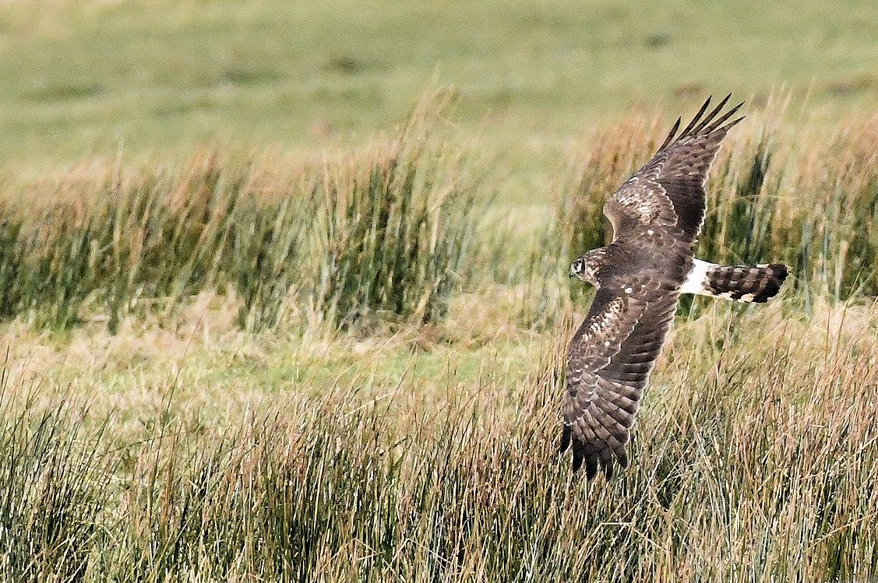
- 3rd February
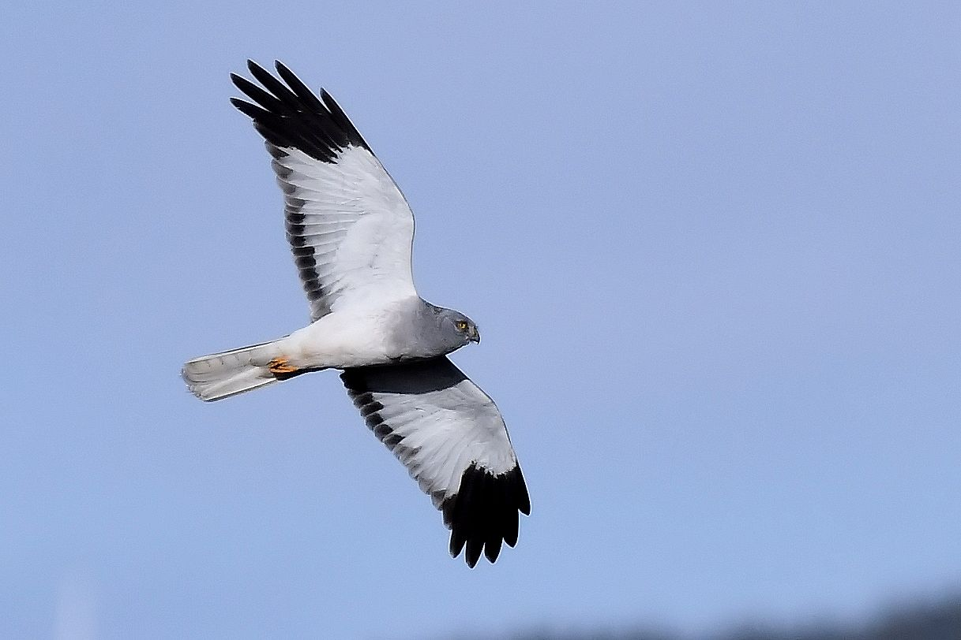
- 12th February
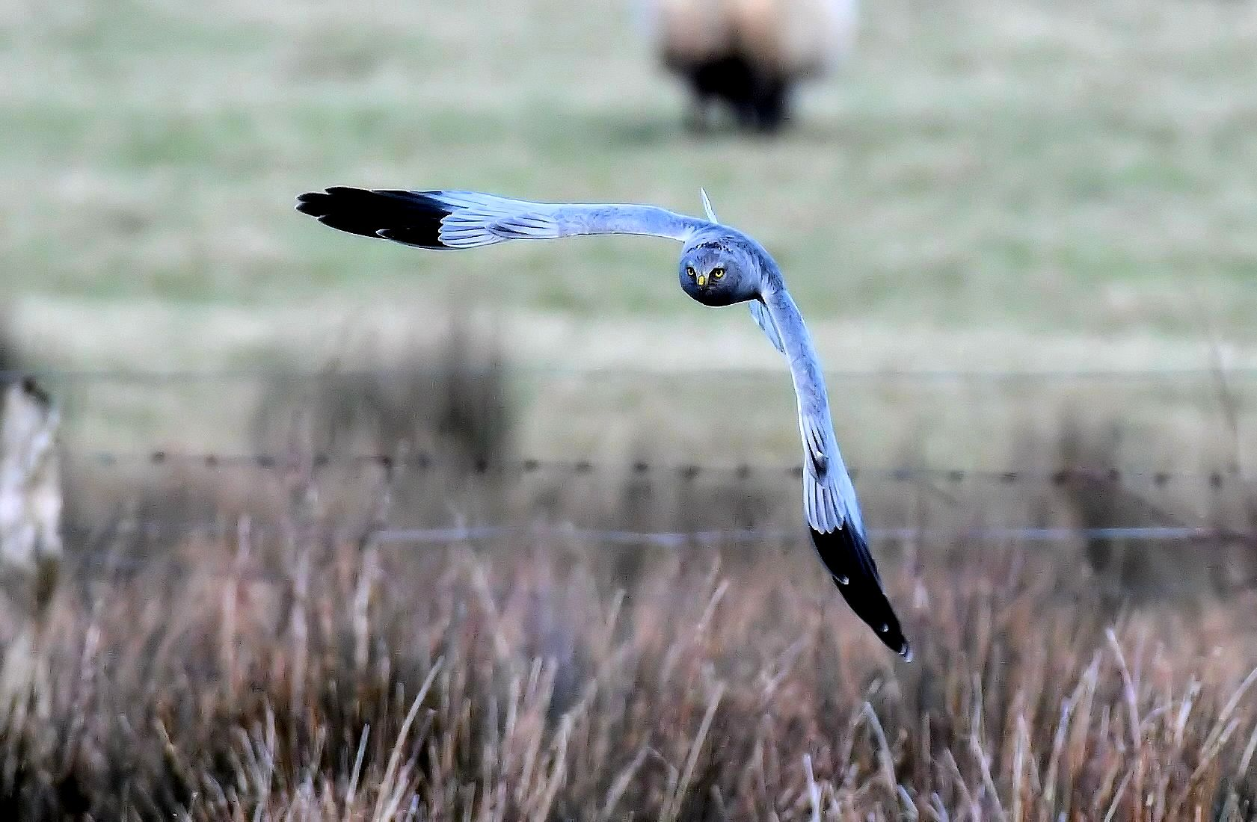
- 15th February

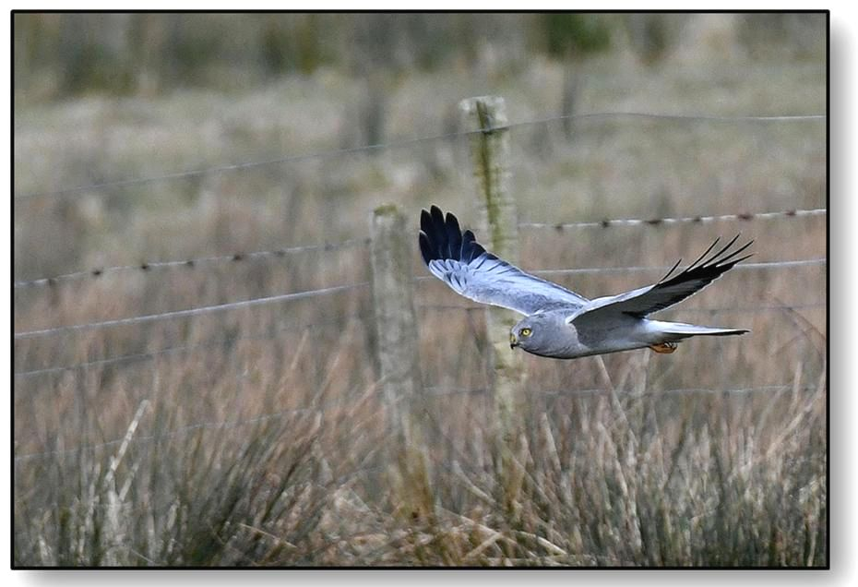
- 15th February

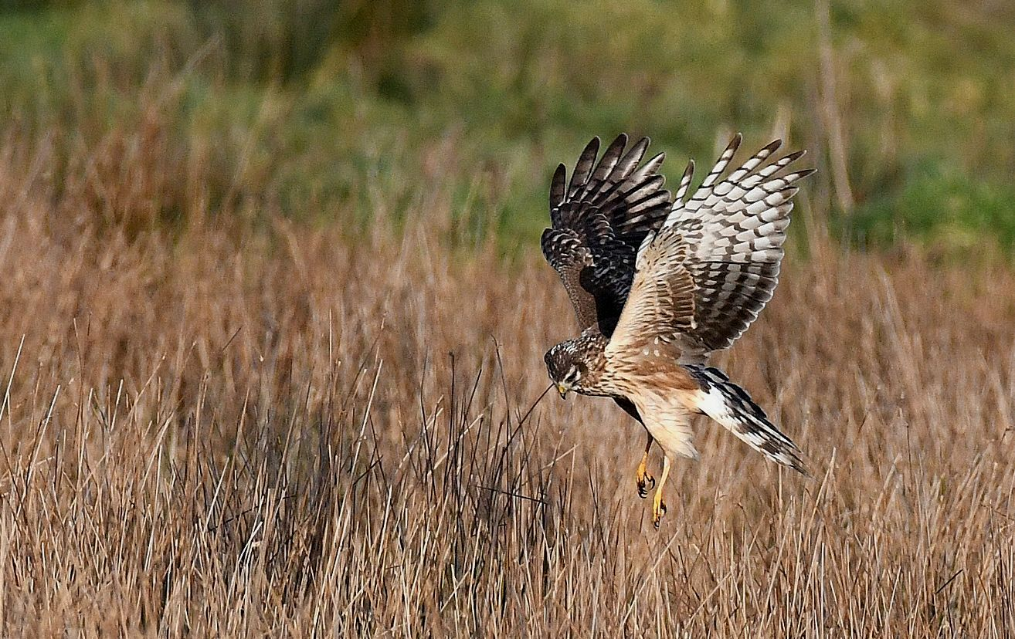
- 20th February
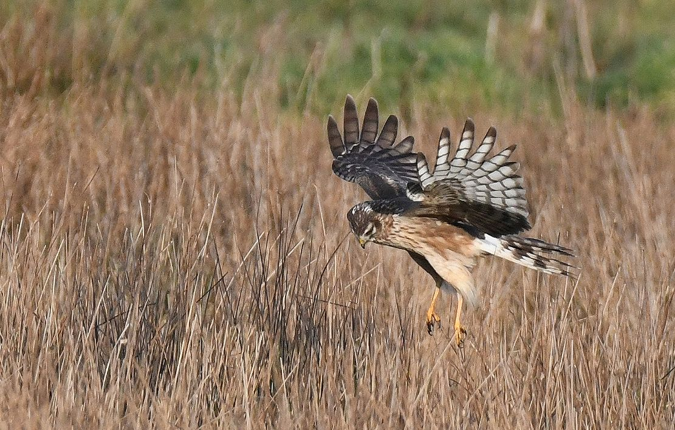
- 20th February

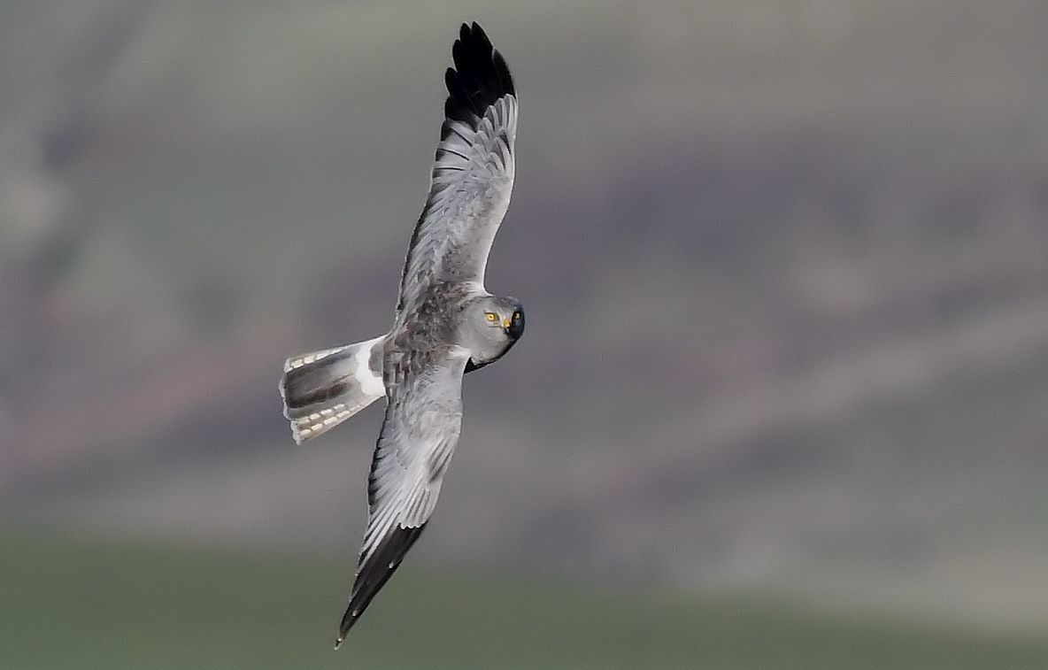
This photo taken in January 2018 was designated ‘Notable’ on www.birdguides.com
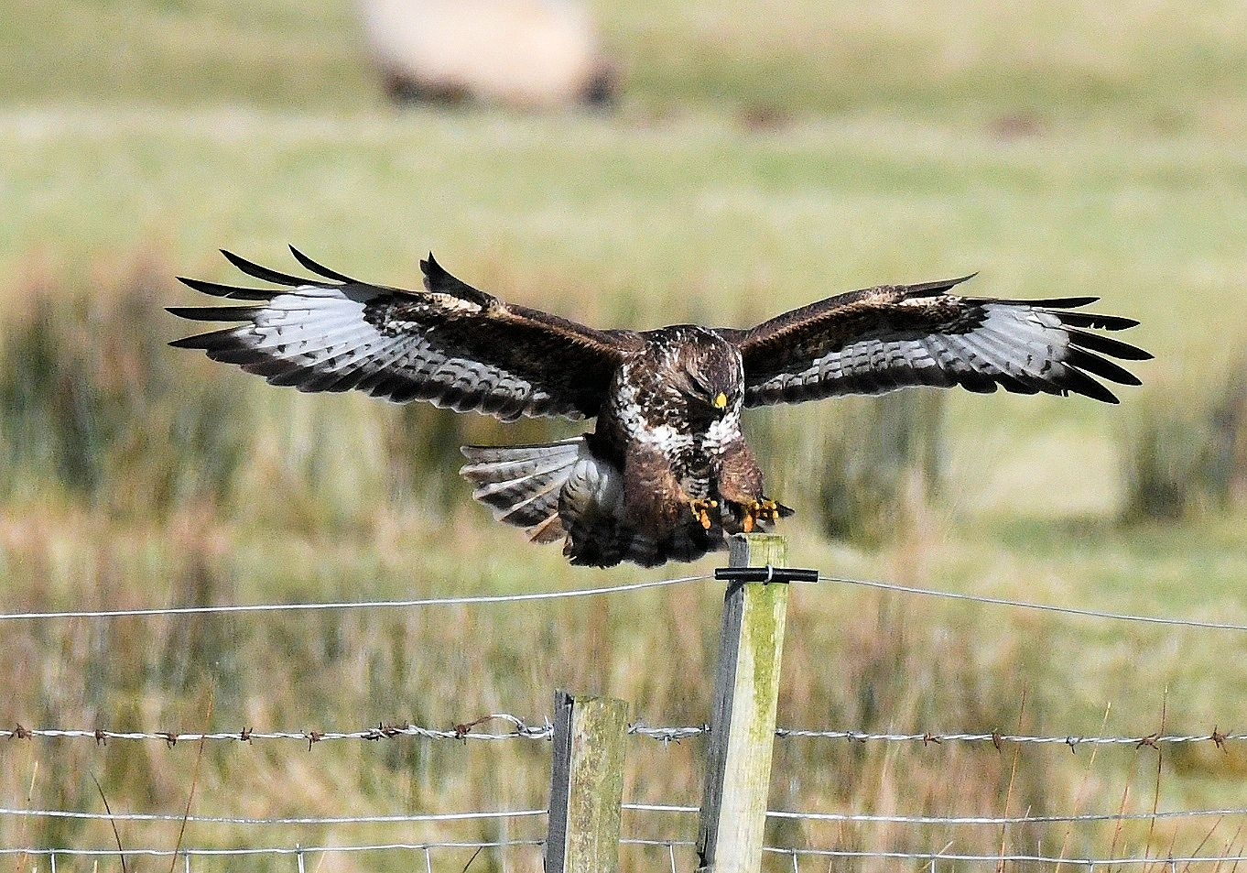
- Common Buzzard Bleachfield TL 12th February

